**Experiment No. 1.1**

**Student Name: Rishav Kumar UID: 22MCC20039**

**Branch: MCA - CCD Section/Group: MCD-1/ Grp A**

**Semester: IV Date of Performance: 18th Jan 24**

**Subject Name: Big Data Analytics Subject Code: 22CAP-782**

1. **Aim/Overview of the practical:**

Hadoop Installation: Ubuntu Operating System in stand-alone mode.

1. **Code for practical:**

* Open terminal in Ubuntu and use following command to install JDK 11

***sudo apt install default-jdk default-jre -y***

* First, create a new user named hadoop:

***sudo adduser Hadoop***

* To enable superuser privileges to the new user, add it to the sudo group:

***sudo usermod -aG sudo Hadoop***

* Switch to the user hadoop:

***sudo su - hadoop***

* Next, install the OpenSSH server and client:

***sudo apt install openssh-server openssh-client -y***

* Now, use the following command to generate private and public keys:

***ssh-keygen -t rsa***

* Now, add the public key to authorized_keys:

***cat ~/.ssh/id_rsa.pub >> ~/.ssh/authorized_keys***

* Use the chmod command to change the file permissions of authorized_keys:

***sudo chmod 640 ~/.ssh/authorized_keys***

* Finally, verify the SSH configuration:

ssh localhost

* Download Hadoop using following command

***wget https://downloads.apache.org/hadoop/common/stable/hadoop-3.3.6.tar.gz***

* Extract the file using the following command:

***tar -xvzf hadoop-3.3.4.tar.gz***

* Next, move the extracted file to the /usr/local/hadoop using the following command:

***sudo mv hadoop-3.3.4 /usr/local/hadoop***

* Now, create a directory using mkdir command to store logs:

***sudo mkdir /usr/local/hadoop/logs***

* Finally, change the ownership of the /usr/local/hadoop to the user hadoop:

***sudo chown -R hadoop:hadoop /usr/local/Hadoop***

* Open the .bashrc file using the following command:

***sudo nano ~/.bashrc***

* Paste following lines in file:

export HADOOP_HOME=/usr/local/hadoop

export HADOOP_INSTALL=$HADOOP_HOME

export HADOOP_MAPRED_HOME=$HADOOP_HOME

export HADOOP_COMMON_HOME=$HADOOP_HOME

export HADOOP_HDFS_HOME=$HADOOP_HOME

export YARN_HOME=$HADOOP_HOME

export HADOOP_COMMON_LIB_NATIVE_DIR=$HADOOP_HOME/lib/native

export PATH=$PATH:$HADOOP_HOME/sbin:$HADOOP_HOME/bin

export HADOOP_OPTS="-Djava.library.path=$HADOOP_HOME/lib/native"

* To enable the changes, source the .bashrc file:

***source ~/.bashrc***

* First, open the hadoop-env.sh file:

***sudo nano $HADOOP_HOME/etc/hadoop/hadoop-env.sh***

* Paste the following lines in the file to add the path of the Java:

export JAVA_HOME=/usr/lib/jvm/java-11-openjdk-amd64

export HADOOP_CLASSPATH+=" $HADOOP_HOME/lib/*.jar"

* Next, change your current working directory to /usr/local/hadoop/lib:

***cd /usr/local/hadoop/lib***

* Here, download the javax activation file:

***sudo wget*** [***https://jcenter.bintray.com/javax/activation/javax.activation-api/1.2.0/javax.activation-api-1.2.0.jar***](https://jcenter.bintray.com/javax/activation/javax.activation-api/1.2.0/javax.activation-api-1.2.0.jar)

* Once done, check the Hadoop version in Ubuntu:

***hadoop version***

* First, open the core-site.xml file using the following command:

***sudo nano $HADOOP_HOME/etc/hadoop/core-site.xml***

* And add the following lines in between <configuration> </configuration>:

<property>

<name>fs.default.name</name>

<value>hdfs://0.0.0.0:9000</value>

<description>The default file system URI</description>

</property>

* Create a directory to store node metadata using the following command:

***sudo mkdir -p /home/hadoop/hdfs/{namenode,datanode}***

* And change the ownership of the created directory to the hadoop user:

***sudo chown -R hadoop:hadoop /home/hadoop/hdfs***

* So first open the configuration file:

***sudo nano $HADOOP_HOME/etc/hadoop/hdfs-site.xml***

* And paste the following line in between <configuration> ... </configuration>:

<property>

<name>dfs.replication</name>

<value>1</value>

</property>

<property>

<name>dfs.name.dir</name>

<value>file:///home/hadoop/hdfs/namenode</value>

</property>

<property>

<name>dfs.data.dir</name>

<value>file:///home/hadoop/hdfs/datanode</value>

</property>

* To do that, first, open the configuration file using the following command:

***sudo nano $HADOOP_HOME/etc/hadoop/mapred-site.xml***

* And paste the following line in between <configuration> ... </configuration>:

<property>

<name>mapreduce.framework.name</name>

<value>yarn</value>

</property>

* First, open the configuration file:

***sudo nano $HADOOP_HOME/etc/hadoop/yarn-site.xml***

* Paste the following in between <configuration> ... </configuration>:

<property>

<name>yarn.nodemanager.aux-services</name>

<value>mapreduce_shuffle</value>

</property>

* Finally, use the following command to validate the Hadoop configuration and to format the HDFS NameNode:

***hdfs namenode -format***

* Start with starting the NameNode and DataNode:

***start-dfs.sh***

* Start the node manager and resource manager:

***start-yarn.sh***

* To verify whether the services are running as intended, use the following command:

***jps***

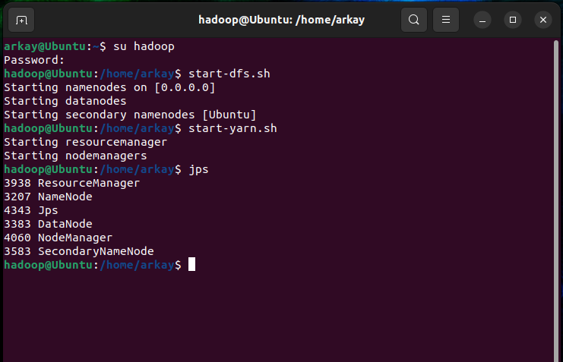

* To access the Hadoop web interface, you will have to know your IP and append the port no 9870 in your address bar:

[***http://server-IP:9870***](http://server-IP:9870)

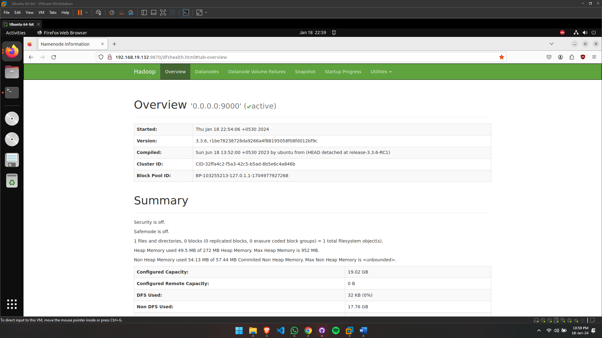

**************************************** **THE END** ***********************************************